**TINKER V. DES MOINES: A LANDMARK CASE**

Directions: Read these three cases that came several decades after the decision in *Tinker v. Des Moines*. Think about how the majority and dissenting opinions might have influenced the decisions in these cases, and then answer the questions at the bottom of the page.

**#1) Beussink v. Woodland R-IV School District (1998)**

**KEY TERMS**

**Landmark Case:** A court case that has a lasting effect on how a certain law or principle is applied.

**Precedent**: An earlier decision that serves as an example or guide to be considered in similar cases that come after it.

**Unconstitutional**: Against the principles of the Constitution.

Brandon Buessink, a junior at Woodland High School, added comments to his personal home page that criticized teachers and administrators at his school. When a student showed Brandon's Web site to a teacher, the teacher was upset by the vulgar language and criticism the site contained. Woodland's principal decided to suspend Brandon for five days due to the "offensive nature" of his site. At the end of the five days, the principal decided to extend Brandon's suspension for 10 more days.

Brandon took his case to U.S. District Court, arguing that the First Amendment's protection of free speech meant his suspension was unconstitutional. District Judge Rodney Sippel agreed. In his ruling, Judge Sippel said that school officials did not "show that its action [suspension of Brandon] was caused by something more than a mere desire to avoid the discomfort and unpleasantness that always accompany an unpopular viewpoint. "

Summarizing his opinion, Judge Sippel concluded, "[t]he public interest is not only served by allowing Beussink's message to be free from censure, but also by giving the students at Woodland High School this opportunity to see the protections of the United States Constitution . . . "

##### **#2) O'Brien v. Westlake City Schools Board of Education (1998)**

Sean O'Brien was a junior at Westlake High School when he created a website, "raymondsucks.org," which criticized his band teacher. When school officials at Westlake accessed the site from school, the assistant principal suspended Sean for 10 days for violating a rule in the Student Conduct Handbook. The handbook stated "students shall not physically assault, vandalize, damage, or attempt to damage the property of a school employee or his/her family or demonstrate physical, written, or verbal disrespect/threat."

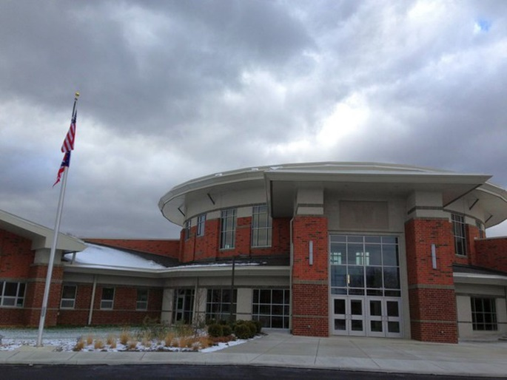As a result of his suspension, Sean's grades plummeted, and he failed band. Believing that the suspension was an unconstitutional violation of the Free Speech Clause of the First Amendment, Sean filed a lawsuit against the school district's board of education. U.S. District Court Judge John M. Manos heard the case and agreed with Sean's lawyer who stated that school officials do not have the authority to regulate speech made by students off campus grounds. While admitting that the case may have been different had Sean "hurled obscenities at his teacher face-to-face on school grounds, in front of other students," the Judge recognized that "the involvement by the school in punishing plaintiff for posting an Internet website critical of defendant . . . raises the ugly specter of Big Brother."

Upon losing the case, school officials expunged Sean's suspension, wrote him a letter of apology for "abridg[ing] students' legitimate exercise of their constitutional rights," and paid Sean $30,000.

##### **#3) J.S. v. Bethlehem Area School District (1998)**

An eighth-grade student in Bethlehem, Pennsylvania was suspended for 10 days before being permanently expelled from middle school as a result of the website he published from his personal computer. This website contained vulgar and derogatory information about several employees from his middle school, asking questions like, "Why should she [his algebra teacher] die? . . . Take a look at the diagram and reasons I give, then give me $20 dollars to help pay for the hitman."

After his expulsion, the student appealed the school board's decision by taking his case to his the Pennsylvania court of common pleas and the Commonwealth Court of Pennsylvania. Claiming a violation of his First Amendment right to free speech, the student and his attorney argued that his expulsion was unconstitutional.

A majority of the Commonwealth Court of Pennsylvania disagreed, stating that the student's website "materially disrupted the learning environment" because at school-sponsored activities and during school students were discussing the site. Furthermore, the court ruled that the medical leave taken by the teacher as a result of the website was clear evidence that the boy's site was distracting.

**Questions:**

1. Who won each of these three cases?
2. Do you agree with each of the rulings? If you were a judge, would you have decided them any differently? Why or why not?
3. How do the decision in the first two cases (*Beussink* and *O’Brien*) demonstrate a legal precedent that comes from the majority opinion found in *Tinker*? Explain your answer.
4. How does the third case (*J.S. v. Bethlehem*) reflect the dissent from Justice Black in the *Tinker* case?
5. How would you balance the rights of students to freedom of expression with the job of schools to provide a disruption-free learning environment? What would you consider to be “disruptive” in school to the point that it should be prohibited?